**How to run name-sorter application in a computer**

1. Download the whole folders of source code name-sorterSolution from GitHub’s url below.
2. Copy the downloads to C:/ drive of a computer

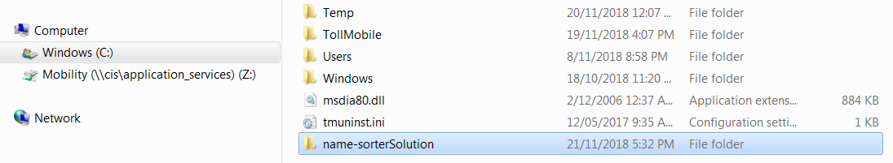

1. The name-sorter.exe is located at Release folder of the source codes

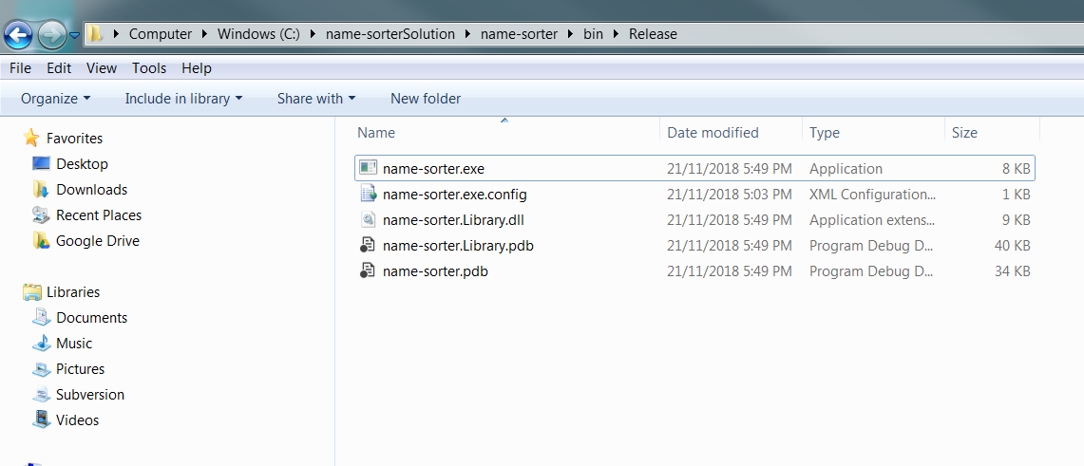

1. Now start up a command window by typing cmd at start up menu and then click enter

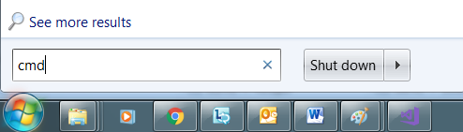

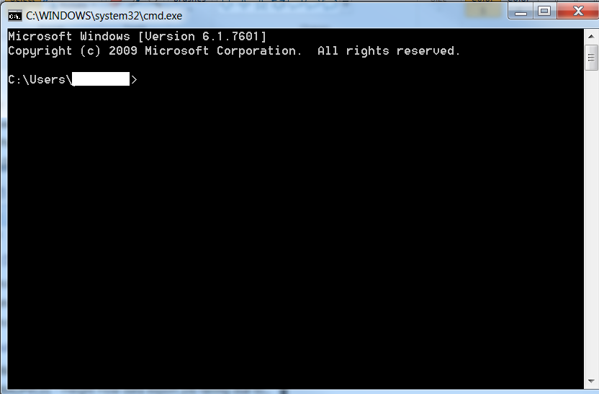

1. Change the directory to the folder where name-sorter.exe is located in step 3 above.

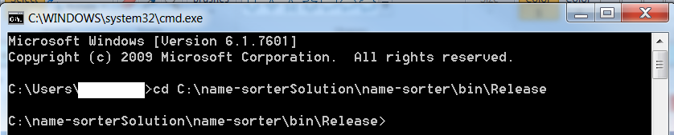

1. A text file containing a unsorted name list needs to be copied to the same folder where name-sorter.exe is located in step 3 above before running name-sorter.exe.

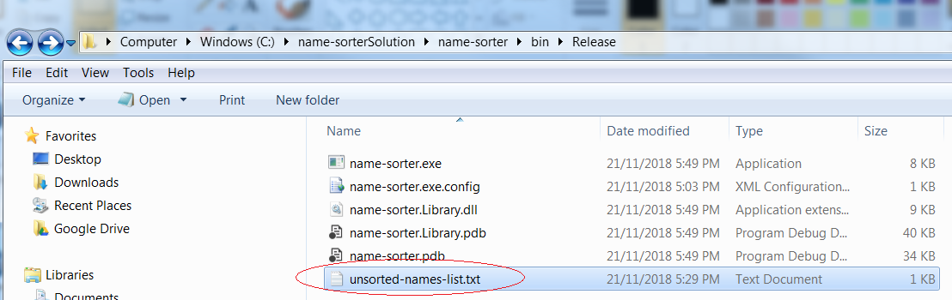

1. Running name-sorter application by typing name-sorter ./unsorted-names-list.txt

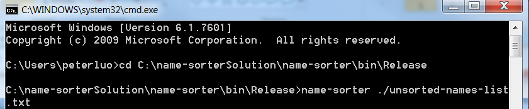

1. Error messages will be displayed if file name is not supplied as command parameter or the file does not exist.

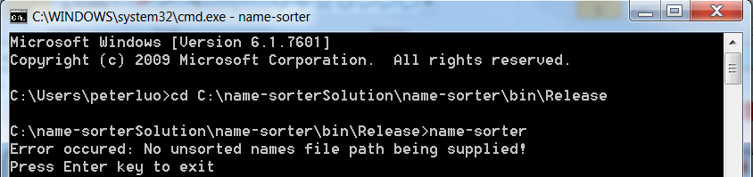

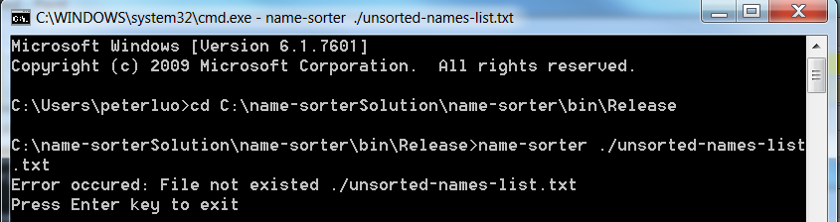

1. When name-sorter is run correctly, a sorted name list will be displayed on screen and a text file of sorted-list.text containing sorted name list will be produced at folder where name-sorter.exe is located in step 3 above.

